Ethan Wieczorek, Nicus Hicks, William Parr

Experiment 1:

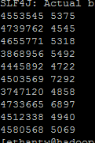

Experiment 2:

